**PROJECT DEVELOPMENT PHASE**

**PROJECT STRUCTURE**

|  |  |
| --- | --- |
| DATE | 29 October 2022 |
| TEAM ID | PNT2022TMID28895 |
| PROJECT TITLE | Smart Lender - Applicant Credibility Prediction for Loan Approval |
| TEAM MEMBERS | |  |  | | --- | --- | | KOTHAI S | 411719104029 | | SHARMILA K | 411719104046 | | KALAIVANI L | 411719104021 | | ASHMITHA R | 411719104004 | |

**Smart Lender - Applicant Credibility Prediction for Loan Approval**

**Project Structure**

Create a Project folder that contains files as shown below

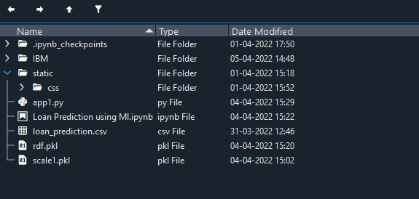

***Project Structure***

* We are building a Flask Application that needs HTML pages “home.html”, “index.html”  stored in the templates folder and a python script app.py  for server-side scripting
* The model is built in the notebook floods.ipynb
* We need the model which is saved and the saved model in this content is floods.save and transform.save
* The templates mainly used here are “home.html”, ”chance.html”, ”no chance.html”, “index.html” for showcasing the UI
* The flask app is denoted as app.py
* IBM scoring endpoint consists of templates and app.py